**MANMEET KAUR**

**HW ASSIGNMENT 2**

**Ques1**’Plot each following group of functions in one graph respectively by Excel,

covering the appropriate domain of x and y.

a. 𝑦 = 𝑒𝑥, 𝑦 = 𝑒―𝑥, 𝑦 = 8𝑥, 𝑦 = 8―𝑥

b. 𝑦 = 0.9𝑥, 𝑦 = 0.6𝑥, 𝑦 = 0.3𝑥, 𝑦 = 0.1𝑥

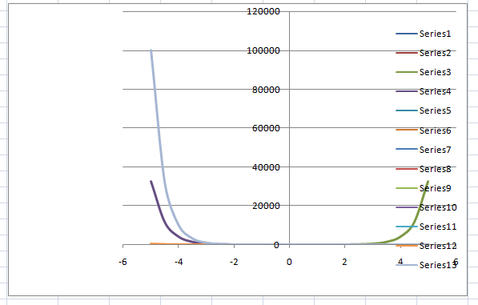

**Ques2**

Given the function: f(x) = 10^x

We need to prove the following expression: (f(x + h) - f(x)) / h = 10^x * (10^h - 1) / h

Step 1: Compute f(x + h)

The function is f(x) = 10^x. So for f(x + h): f(x + h) = 10^(x + h) = 10^x * 10^h

Step 2: Apply the Difference Quotient

Now we apply the difference quotient formula: (f(x + h) - f(x)) / h

Substituting in the expressions for f(x + h) and f(x): = (10^x * 10^h - 10^x) / h

Step 3: Factor out 10^x

= (10^x * (10^h - 1)) / h

Final Result

Thus, we have: (f(x + h) - f(x)) / h = 10^x * (10^h - 1) / h

If the two lines (from columns E and F) are close or overlap, it shows that the difference quotient converges to the derivative, thus proving the relationship.

**Ques3**

As x → ∞, f(x) = x^5 grows exponentially faster than g(x) = 5x. The degree of the polynomial in f(x) (which is 5) causes it to increase at a higher rate compared to the linear g(x). In conclusion, f(x) = x^5 grows more rapidly than g(x) = 5x for large x.

**Ques 4**

Introduction

In this report, we will explore the function f(x) = 1/e^(1/x) and demonstrate that it is an odd function. An odd function is defined by the property f(-x) = -f(x) for all x in its domain.

Data Collection

To investigate the properties of f(x), we calculated the values of f(x) and f(-x) for a range of x values from -5 to 5, excluding zero to avoid division by zero errors. The values were calculated as follows:

For f(x): f(x) = 1/e^(1/x) for x ≠ 0

For f(-x): f(-x) = 1/e^(1/(-x)) for x ≠ 0

For -f(x): -f(x) = -1/e^(1/x)

Graphical Representation

To visually confirm the relationship, we plotted the functions f(x), f(-x), and -f(x) on a graph in Excel. The graph shows that for each positive value of x, f(-x) mirrors -f(x), confirming that the function is indeed odd.

Conclusion

From both our calculations and the graphical representation, we can conclude that the function f(x) = 1/e^(1/x) satisfies the condition for being an odd function, as demonstrated by f(-x) = -f(x) for all x in its domain.

**Ques5**

**changing Parameter b**

As the parameter b increases, the function f(x) approaches its maximum value more quickly. This results in a steeper ascent of the graph, indicating that the function's growth rate increases.

Conversely, when b decreases, the graph becomes flatter, and the function approaches its maximum more gradually.

**Changing Parameter a**

The parameter a affects the horizontal shift of the graph. As a increases, the graph shifts to the left, causing the function to attain its maximum value at smaller x values.

Conversely, decreasing a shifts the graph to the right, requiring larger x values for the function to reach its maximum.

**Observations**

The function is asymptotic, meaning it approaches a maximum value but never reaches it. The specific behaviors of the graph demonstrate the interplay between a and b in shaping the overall function.

**QUES 6**

The function is defined as:

g(x) = x^6 + x^4, x ≥ 0

Finding the Inverse Function:

To find the inverse function g⁻¹(y), we start by setting g(x) = y:

y = x^6 + x^4

Rearranging gives us:

x^6 + x^4 - y = 0

**QUES 7**

The function for the charge of the capacitor is given by:

Q(t) = Q₀(1 - e^(-t/a))

To find the inverse function, we first set y = Q(t):

y = Q₀(1 - e^(-t/a))

Rearranging the equation for t:

Isolate e^(-t/a):

y/Q₀ = 1 - e^(-t/a)

e^(-t/a) = 1 - (y/Q₀)

Take the natural logarithm on both sides:

-t/a = ln(1 - (y/Q₀))

t = -a ln(1 - (y/Q₀))

Thus, the inverse function Q^(-1)(y) is:

Q^(-1)(y) = -a ln(1 - (y/Q₀))

Meaning of the Inverse Function:

The inverse function Q^(-1)(y) provides the time t required to charge the capacitor to a specified charge y. For a given amount of charge y (expressed as a fraction of Q₀), it allows us to determine how long it takes for the capacitor to reach that charge.

Part B: Time to Recharge to 90% of Capacity

To find the time required to recharge the capacitor to 90% of its capacity when a = 2:

Set y = 0.9Q₀: t = -2 ln(1 - 0.9) = -2 ln(0.1)

Calculate t: t ≈ -2 ln(0.1) ≈ -2 × (-2.3026) ≈ 4.6052 seconds

Thus, it takes approximately 4.61 seconds to recharge the capacitor to 90% of its capacity.